* **Connect to the Store Sales Data and do the following: -**

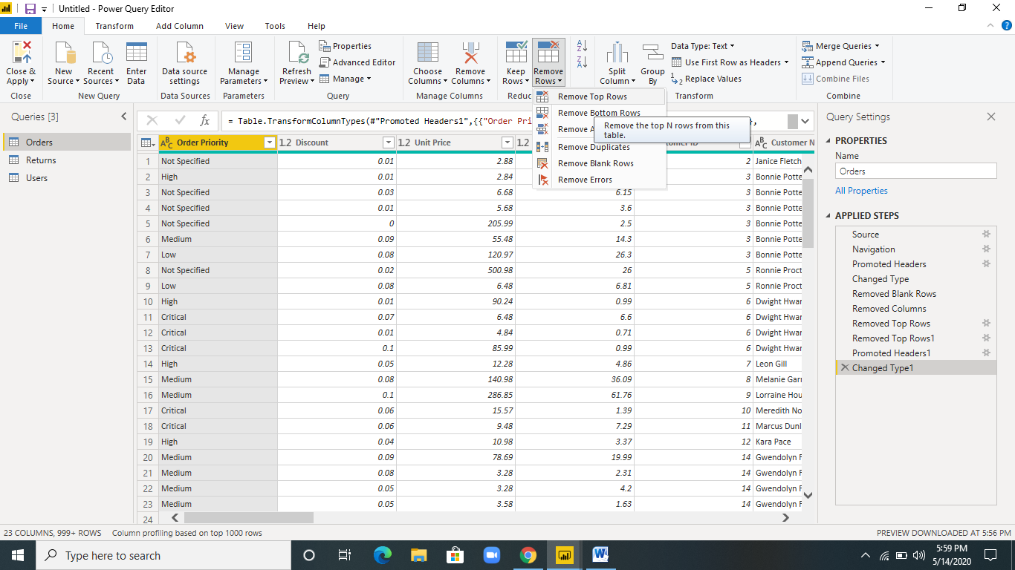

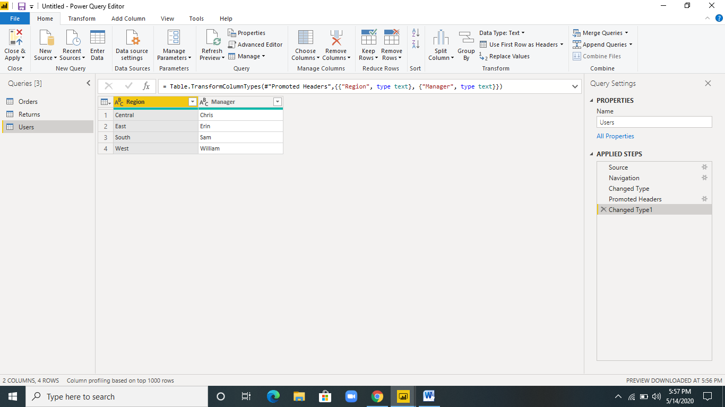

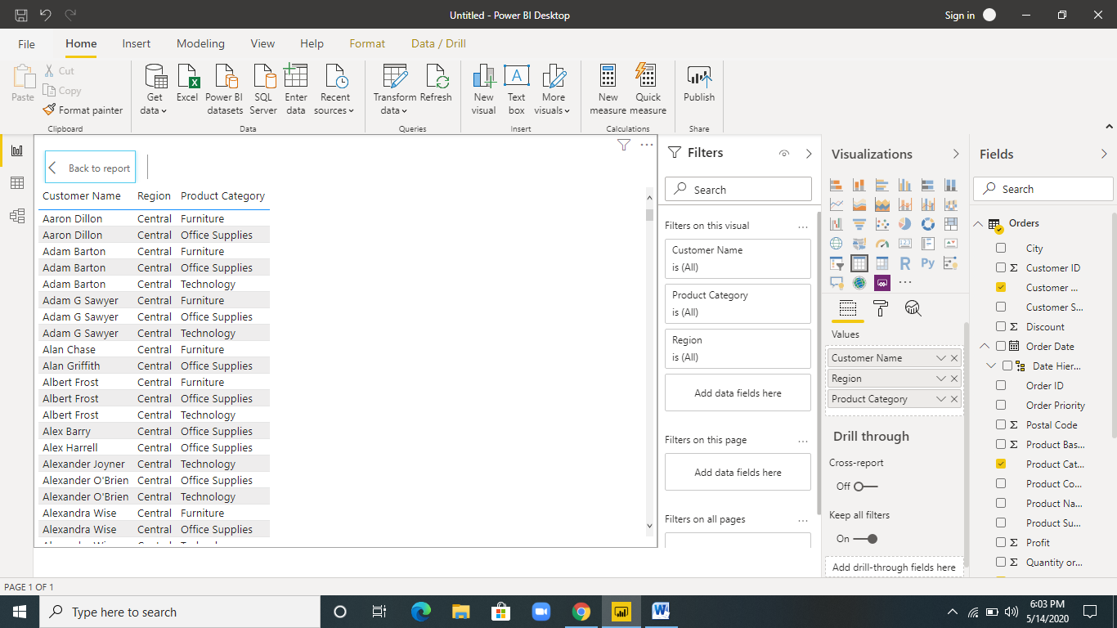

* **Create a line and Clustered Column Chart showing the Sales and Discount as per the State or Province**

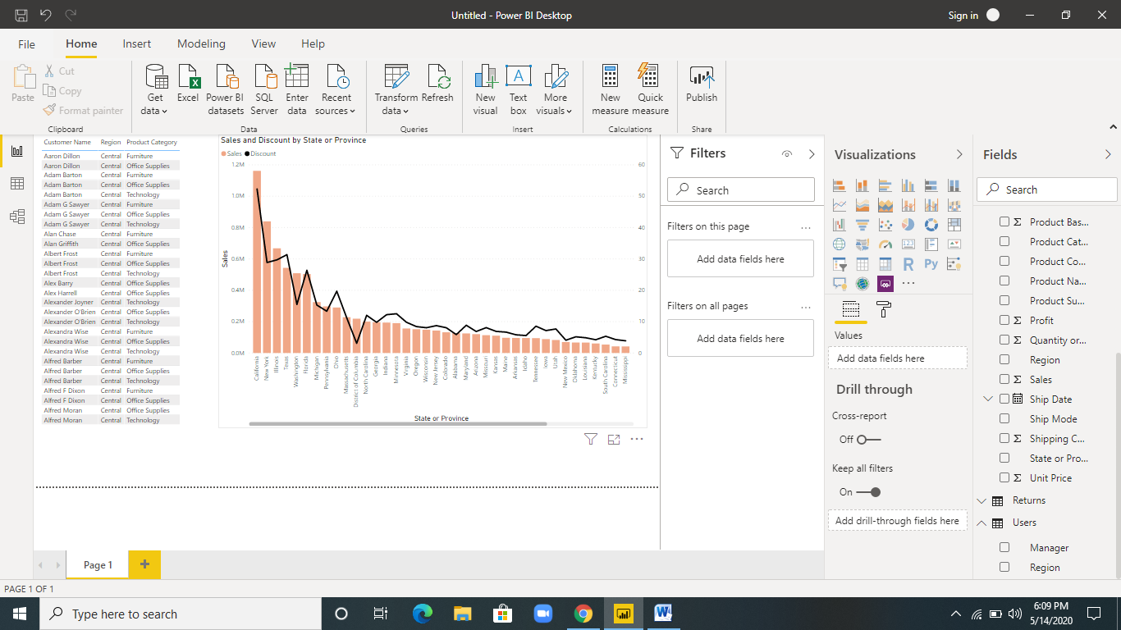

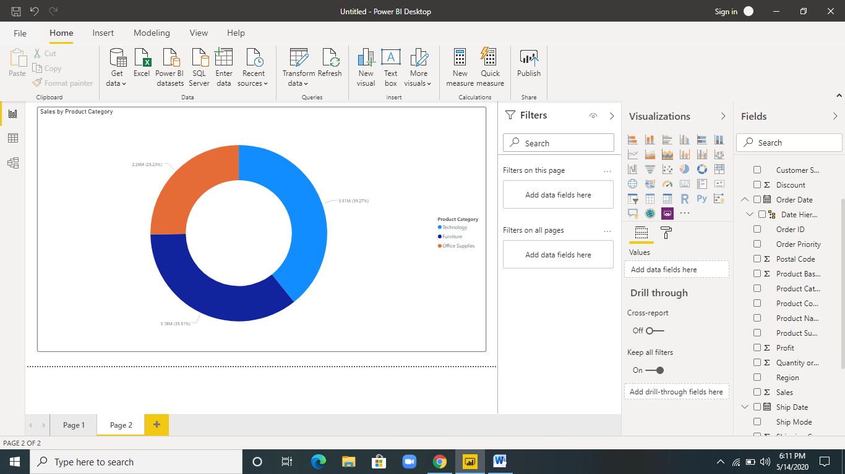

* **Create a Slicer and show the regions in dropdown. See how all the visuals mentioned above behaving when a particular region is selected.**

